Ideal Project

Design link - http://www.idealconnection2201.firstcomdemolinks.com/

1. Customer Module

* Create customer module based on design “Profile module”.

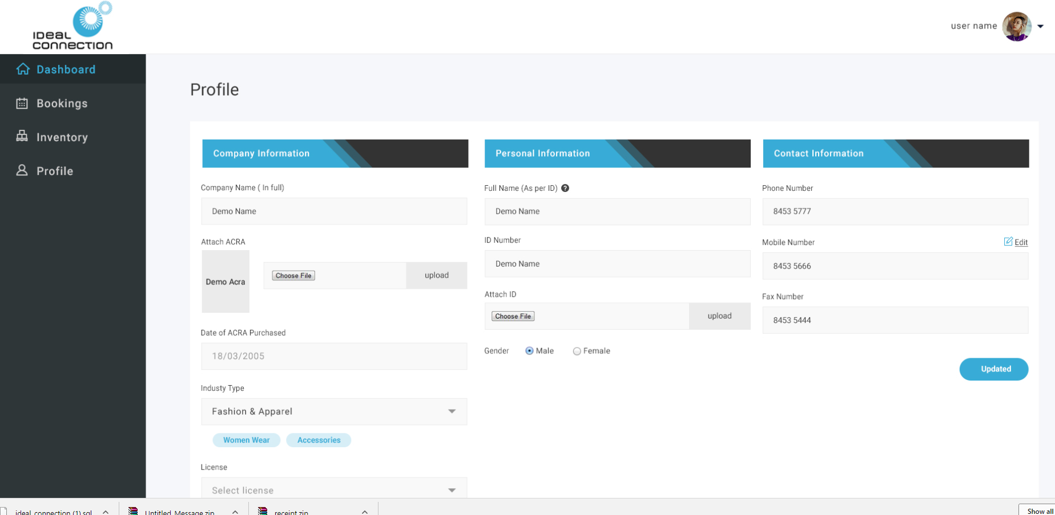

1. Booking Module X

* Use existing “Appointment Module” change to “Booking module”.

1. Discount Module X

* Create discount module to allow user to create discount code.

1. Booth Module

* Add new tab “Upload File” to allow user to upload file.
* Add new tab “Booking Information” to show history and upcoming booking in calendar.

1. Location Module X

* Remove unit number
* Add dropdown list call “location type”

Option – “Bus Interchange”, “MRT Station”, “Raffles I Tanjong Pagar Exchange” and Other Location

1. Location Type X

* Create location type module allow user can add, update and remove.